 |  | Newsletter
Vision: All third agers living meaningful and happy lives. | Mission: Provide learning and enrichment  activities and programmes for third agers. |  | Learning Communities: Members meet at  monthly learning sessions on a specific subject
Outreach Programme  Library Talks by U3A SACE for 2nd half of 2019  REALITIES OF AGING  1st Wednesday of the month, 2pm to 3pm.  3 July 2019 Library@Chinatown,  7 Aug 2019 Toa Payoh Public Library  4 Sep 2019 Ang Mo Kio Public Library  2 Oct 2019 Sembawang Public Library  6 Nov 2019 Clementi Public Library  4 Dec 2019 Tampines Regional Library  YOU AND YOUR BODY  2nd Wednesday of the month, 2pm to 3pM  10 Jul 2019 Bukit Panjang Public Library  14 Aug 2019 Queenstown Public Library  11 Sep 2019 Bedok Public Library  13 Nov 2019 Clementi Public Library  11 Dec 2019 Woodlands Regional Library  MONEY WISDOM  3rd Wednesday of the month, 2pm to 3pm  17 Jul 2019 Bishan Public Library  21 Aug 2019 Sembawang Public Library  18 Sep 2019 Central Public Library  16 Oct 2019 Ang Mo Kio Public Library  20 Nov 2019 Library @ Harbourfront  All the above one-hour talks will be conducted separately by Adrian Teo, Irene Wee, Elaine Tan and Ann Marie.  Visit us at the coming NSA Road Show  Membership subscription at a promotional rate | Up Coming Events  FloorCurling  This is a new sport suitable for all ages, adapted for both physically fit and physically challenged. FloorCurling is a world wide game played as a competitive sport, also a social game to promote communication and team building. Come and experience for yourself on 5 August 2018 at 10am at Singapore Sports Hub @Stadium Drive, OCBC Arena. Just gather yourselves with your families on that day and meet our fellow members and have fun. Bring your socks for this exercise.  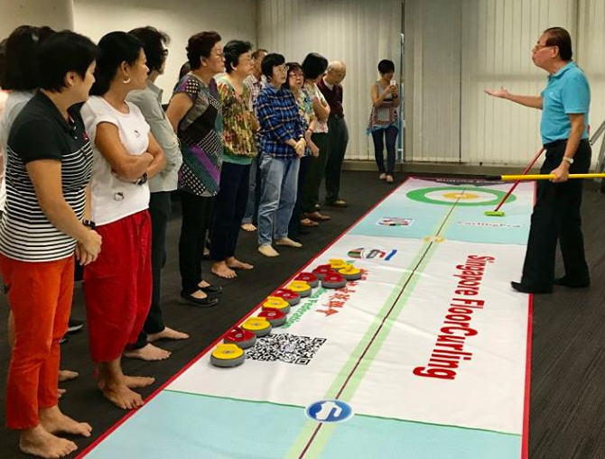  FloorCurling demonstration for SACE in 2018  Resistance Band Training  Back by popular demand! Starting 1 August we will run 6 sessions on each Thursday till 5 September. As this is a HPB sponsored programme we can only accept those who have not attended before, up to 16 pax. Please register with us early.
Issue 55 WHERE TEACHERS ALSO LEARN & LEARNERS ALSO TEACH July 2019
U3A Singapore Monthly Newsletter July 2019

Film & Discussion  Always Be My Maybe  Childhood sweethearts have a falling out and don't speak for 15 years, only reconnecting as adults when Sasha runs into Marcus in San Francisco. Although the old sparks are still there, the couple live in different worlds.  Date: Tuesday 16th July  Time: 2.30 pm  Venue: Peninsula Plaza  Genre: Romantic Comedy  Duration: 1 hr 42 mins  Facilitator: Dennis Carroll  _____________________________  Decoupage Workshop  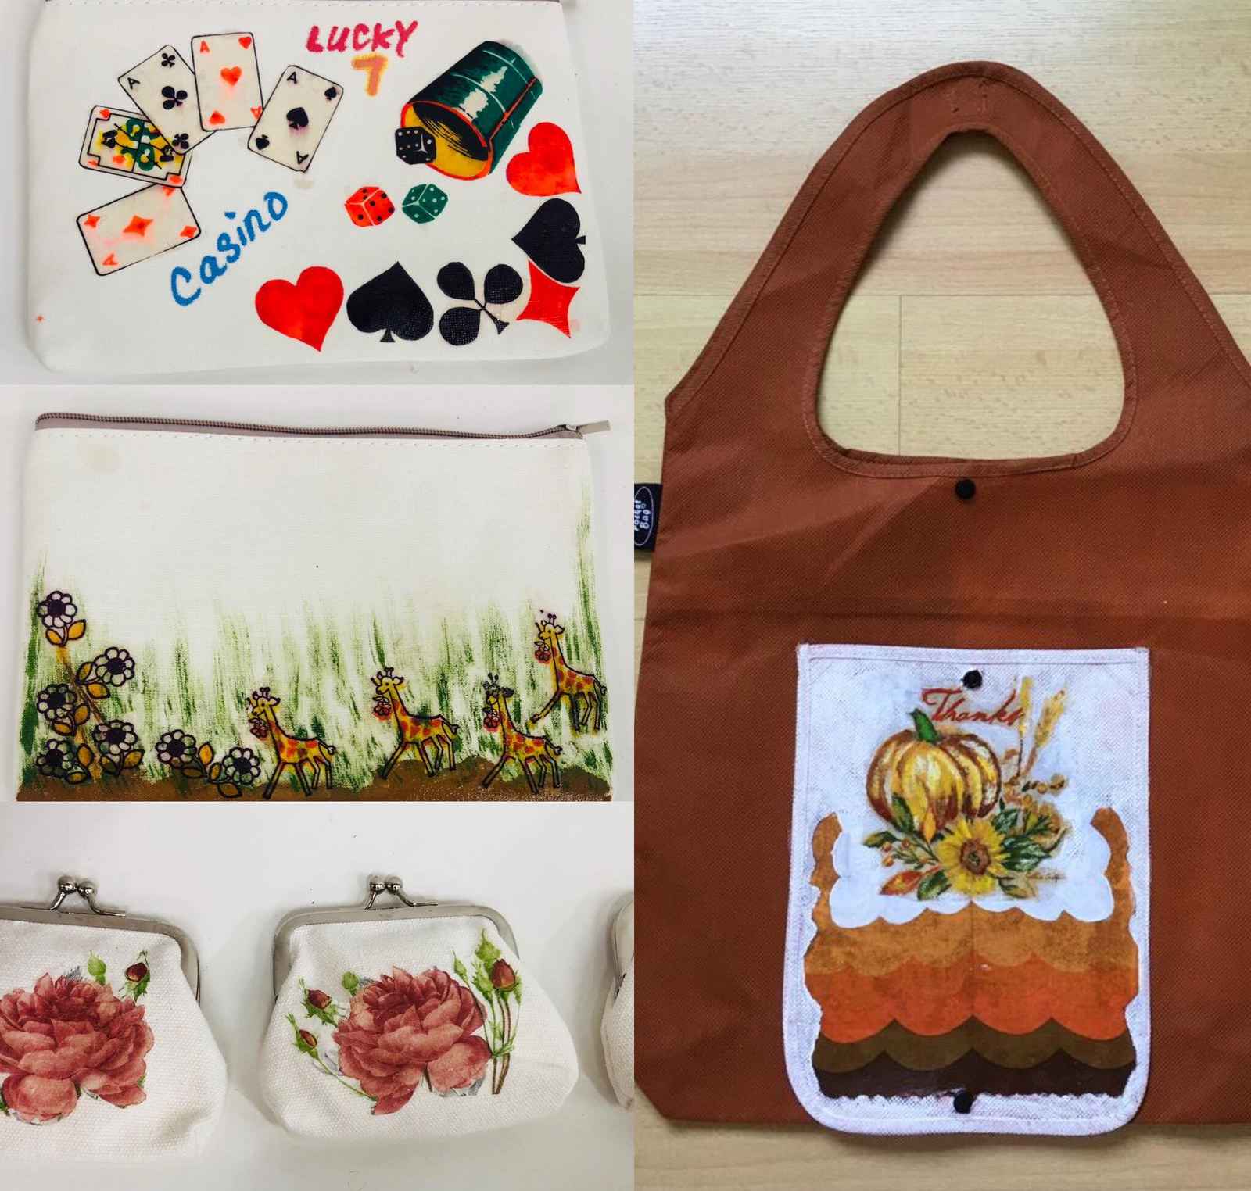  Decorating new or up-cycled collectible items with napkins to create paint effects. Must pre-register.  Date: Friday 12th July 10.30am – 12.30 pm  Venue: Peninsula Plaza  Material fee: from $5  Facilitator: Serene Low | Ramble  Julong Lake Gardens  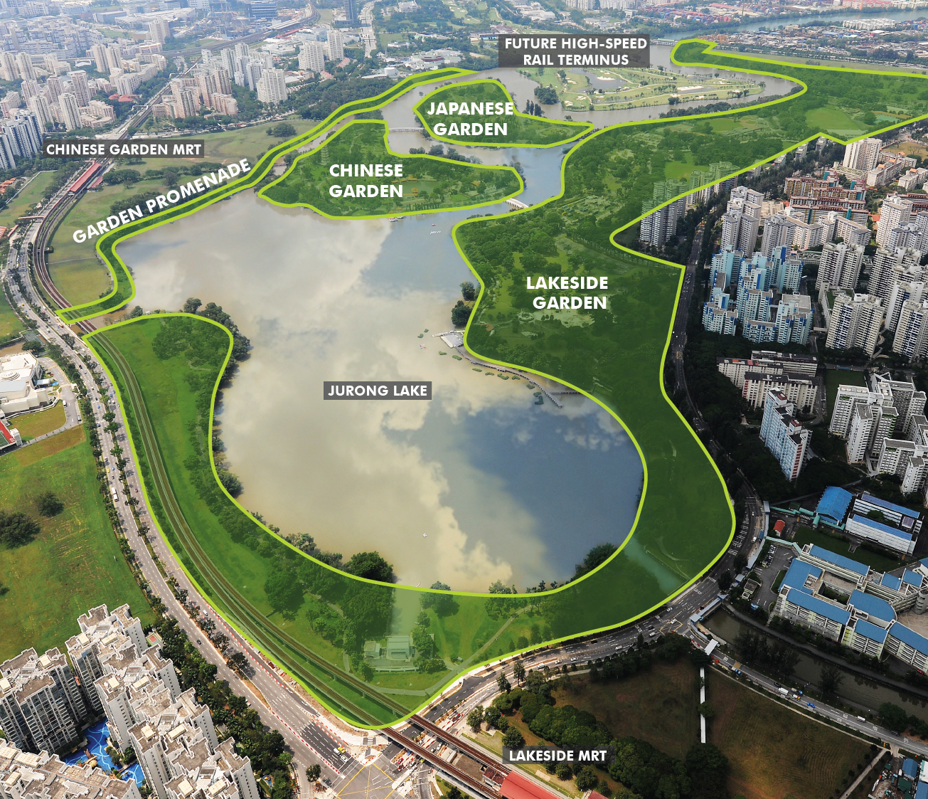  Jurong Lake Gardens is located within the larger Jurong Lake District which is envisioned as a district of gardens and water comprising Lakeside Gardens, Chinese and Japanese Gardens and Garden Promenade.  Date: Sunday 21st July  Time: 4 pm  Meet At: Lakeside MRT  Facilitator: Julie Lim  ___________________  Photo Outing  Windsor Nature Park @Venus Drive, Upper Thomson  Capture the beauty of flora and fauna with your viewfinder.  Date: Tuesday 16th July.  Meet At : Entrance to Windsor Park  Time: 8 am  Facilitator: To Chee Kan | Events Update  Bicentennial Experience  We have booked a number of tickets for 18th July, for members to enjoy the experience together. Collect your tickets at SACE centre, before they run out.  ______________  Fujian Tour 21 Oct to 28 Oct 2019  From U3A Travel Community: organised by the community, for the community.  We are pleased to note that this tour is confirmed as we have hit the minimum pax required. Those who are interested can still contact Elaine Tan @96353030.  _____________  Quotable Quote  Doing what you like is Freedom  Liking what you do is Happiness  ____________  Your experience with U3A activities is important. Feel free to share with us in this space. Elaine Tan @ 96353030 for contact.  www.sace.org.sg  https://www.facebook.com/sace.sg
U3A SINGAPORE JULY 2019 ACTIVITIES
DATE | ACTIVITIES | VENUE |  | TIME |  | FEE members/guests
Please also refer to our weekly circular for latest update.
Every Tue, except movie screening day | Rummikub Game |  | Peninsula Plaza |  | 2.30 pm -5.30 pm |  | Free/$5
1st Sat of the month Session 1  3rd Sat of the month Session 2 | Rummikub Game |  | Peninsula Plaza |  | 10 am - 1 pm |  | Free/$5
4^{t} th Friday of the month | Ukulele Jamming |  | Peninsula Plaza |  | 7 pm to 9 pm |  | Alumni members
2nd Sun of the month Session 1  4th Sun of the month Session 2 | Singmaster Club |  | Peninsula Plaza |  | 2 pm – 4.30 pm |  | Alumni members
Every Thursday | Resistance Band Training |  | Peninsula Plaza |  | 4.30pm – 5.30pm |  | Members
Friday 12 July | Decoupage class |  | Peninsula Plaza |  | 10.30am – 12.30 pm |  | Material Fee: $5+
Tues 16 July | Photo Outing – Windsor Park |  | Entrance of the Park |  | 8 am |  | Alumni members
Tues 16 July | Film – Always Be My Maybe |  | Peninsula Plaza |  | 2.30 pm |  | Members
Sun 21 July | Ramble – Jurong Lake Gardens |  | Lakeside MRT |  | 4 pm |  | Free

