 |  | Newsletter
Vision: All Third Agers living meaningful and happy lives. | Mission: Provide learning and enrichment  activities and programmes for third agers. |  | Learning Communities: Members meet at  monthly learning sessions on a specific subject
When: Friday 27th December 2019  Where: Polaris Ballroom (Level One)  Novotel Stevens  28 Stevens Road  Time: 6pm to 11pm (Registration starts at 6pm, 7pm event  starts)  Event Details:  - 7 course scrumptious Chinese dinner prepared by the hotel’s award-winning chef and his team.  - Performances by the 3 winners of this year’s Seniors Got Talent competition.  Ticket Details:  - Early Bird for members only: $45 per head (15th Nov to 30th Nov)  - Spouse/partner/non-members: $60 per head (15th Nov to 30th Nov)  - Members: $60 (1st Dec to 15th Dec)  - $90 per head (16th Dec to 20th Dec)  - No ticket sales after 20th Dec.  Contact office for details, registration and ticket sales.  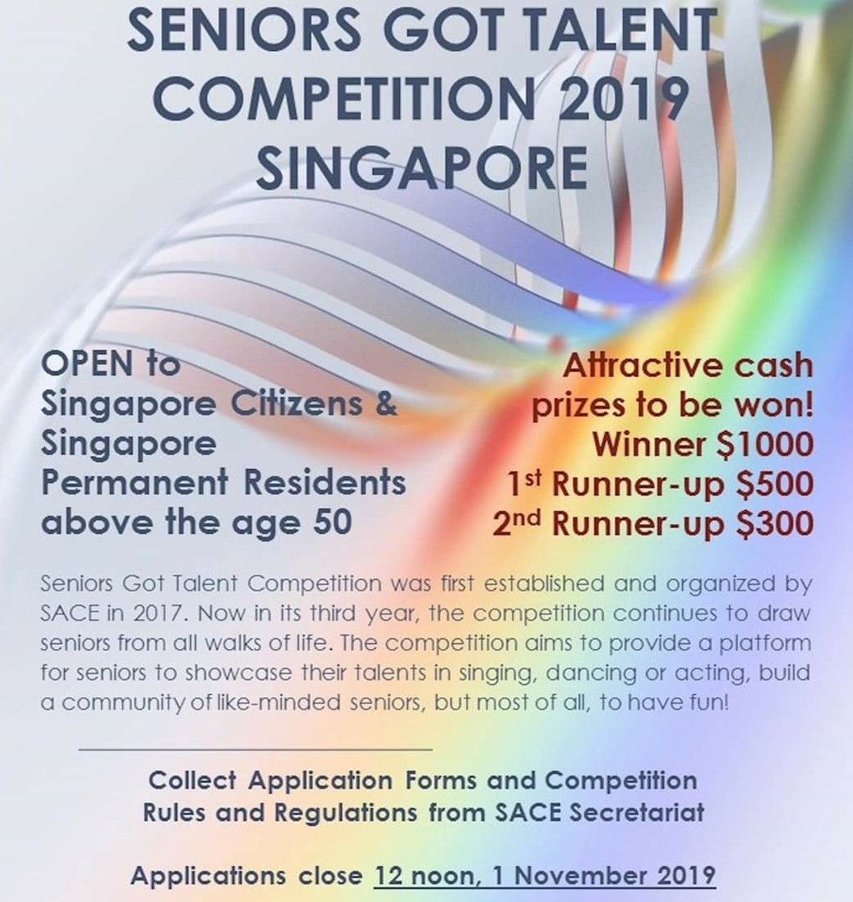 | Experimental Arts Theatre (E.A.T.), as you may recall, assisted us with our skit performance during our 2019 Symposium in April. They have come up  with another play called Alone, Lonely, Loneliness, on 9th November @5pm and 10th November @8pm. SACE has received 80 priority passes for the two days performances, courtesy of E.A.T. Passes are available from our office on a first come first basis, limited to 2 for each member.  ******  Our past events for last month with free entries to Lim Boon Keng Musical and 2019 Miss World Singapore Grand Coronation Night were well attended by our SACE members and friends.  ******  Library Talks for the month of November  Reality of Aging Speaker: Mr Adrian Teo  Where: Clementi Public Library  When: 6th November 11am to 12noon  You and Your Body Speaker: Ms Irene Wee  Where: Clementi Public Library  When: 13th November 2pm to 3pm  Money Wisdom Speaker: Ms Elaine Tan  Where: Harbourfront Public Library  When: 20th Nov 2pm to 3pm
Issue 59 WHERE TEACHERS ALSO LEARN & LEARNERS ALSO TEACH Nov 2019
U3A Singapore Monthly Newsletter Nov 2019

Film & Discussion  Saving Mr Banks  Spurred on by a promise he made to his daughters, Walt Disney (Tom Hanks) embarks on what would become a 20-year quest to obtain the movie rights to "Mary Poppins." The author, P.L. Travers (Emma Thompson), proves to be an uncompromising curmudgeon who has no intention of letting her beloved characters become mangled in the Hollywood machine. However, when the books stop selling and she finds herself in need of money, Travers reluctantly agrees to consider Disney's proposition.  Date: Tuesday 19th Nov  Time: 2.30 pm  Venue: Peninsula Plaza  Genre: Comedy / Drama  Duration: 125 mins  Facilitator: Dennis Carroll  ******  Decoupage Workshop  Decorating new or up-cycled collectible items with napkins to create paint effects.  Must pre-register  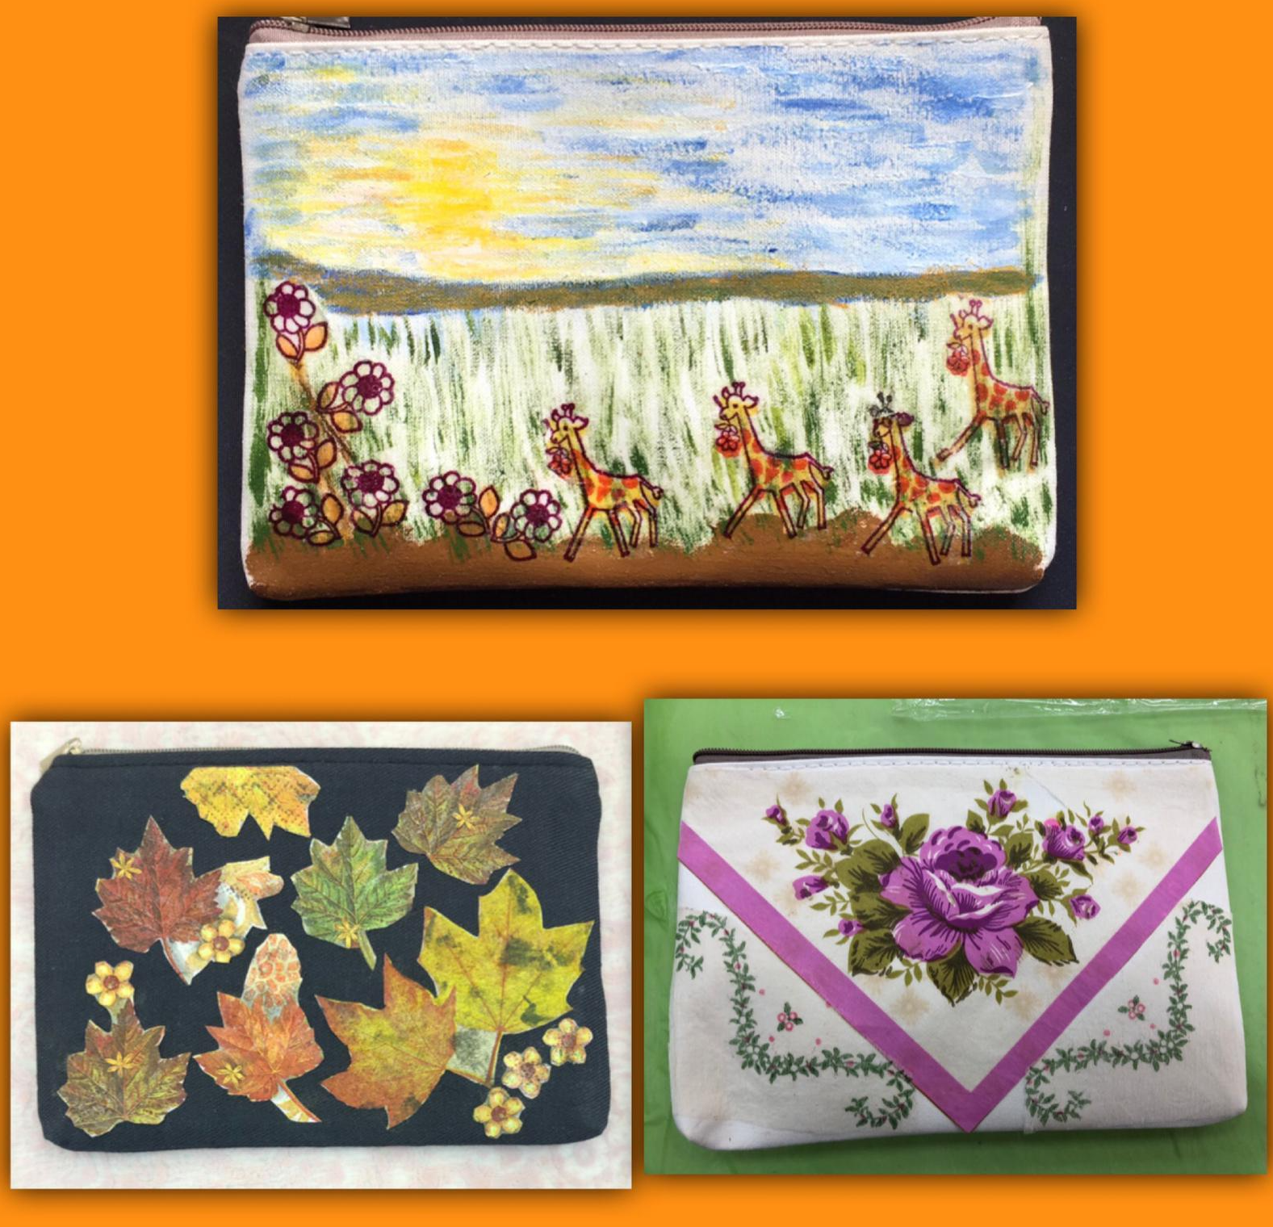  Date: Wednesday 13th Nov 10.30pm –12.30pm  Venue: Peninsula Plaza  Material fee: From $5  *****  There will be noPhoto Outing for the month of November. | Ramble  Jurong Central Park  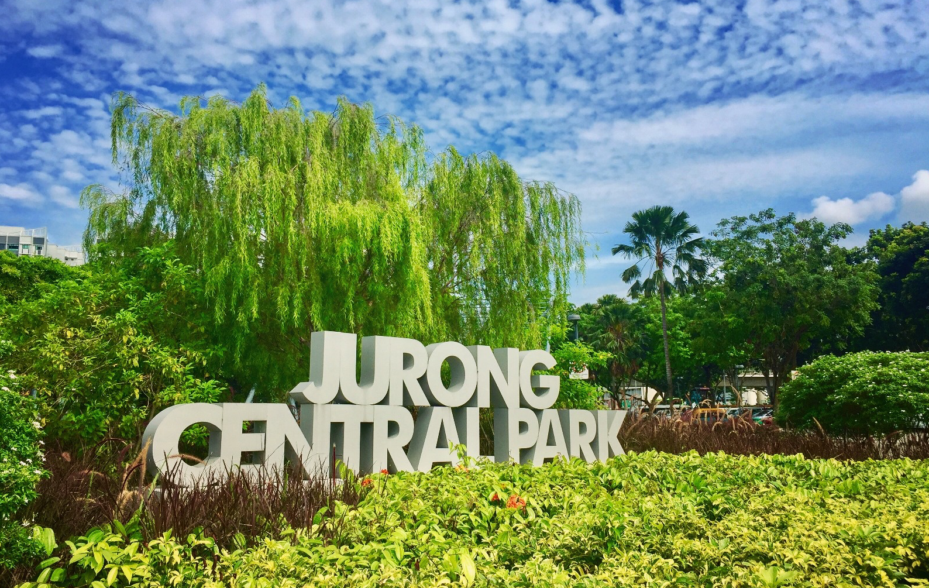  With the life-sized Snakes and Ladders playground and Ludo Garden, the park allows visitors to revisit their childhood and relive their favourite memories. Nature lovers can also explore and discover the various types of aquatic plants, wildlife species and dragonflies that thrive in the ponds located in the park.  Date: Sunday 17th Nov  Time: 4 pm  Meet At: Boon Lay MRT  Facilitator: Julie Lim  ******  Activities Date/Time  Rummikub Every Tuesday 2.30pm – 5.30pm Except movie screening day  1st and 3rd Saturday of the month  10am – 1pm  Ukulele Jamming 4th Friday of the month 7pm – 9pm  Singmaster Club 2nd & 4th Sunday of the month. 2pm – 5pm  Other Activities  *****  www.sace.org.sg  https://www.facebook.com/sace.sg | Travel Community  Fujian Cultural Tour  21st Oct to 28th Oct  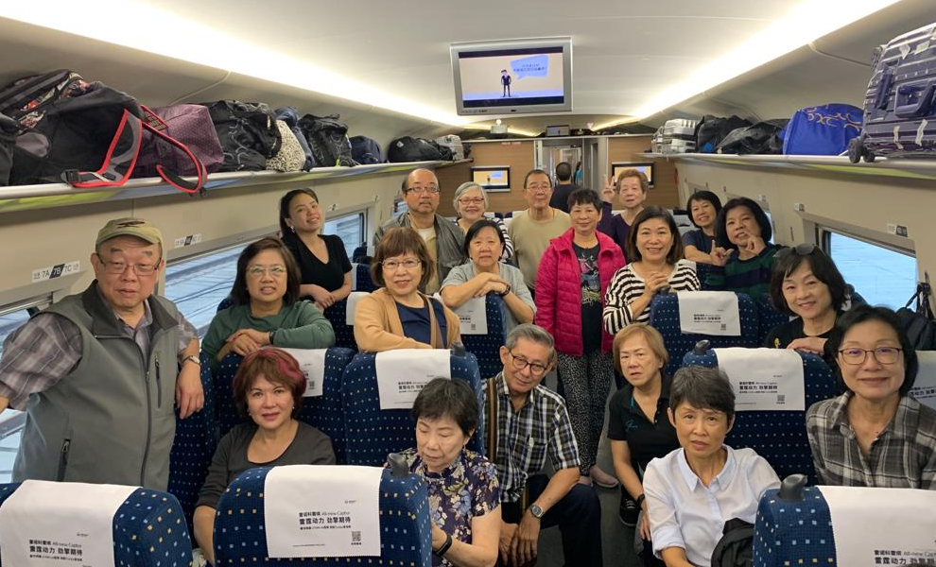  20 pax on board the plane rearing to go.  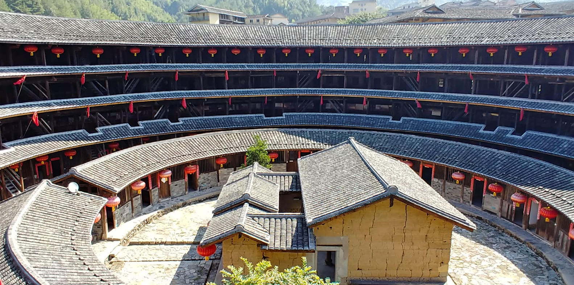  Hakka round house土楼 @ YongDing viewed from 4th level.  Bamboo rafting at Mt Wuyi.  Meandering along the JiuQu Xi九曲溪 towards sunset.  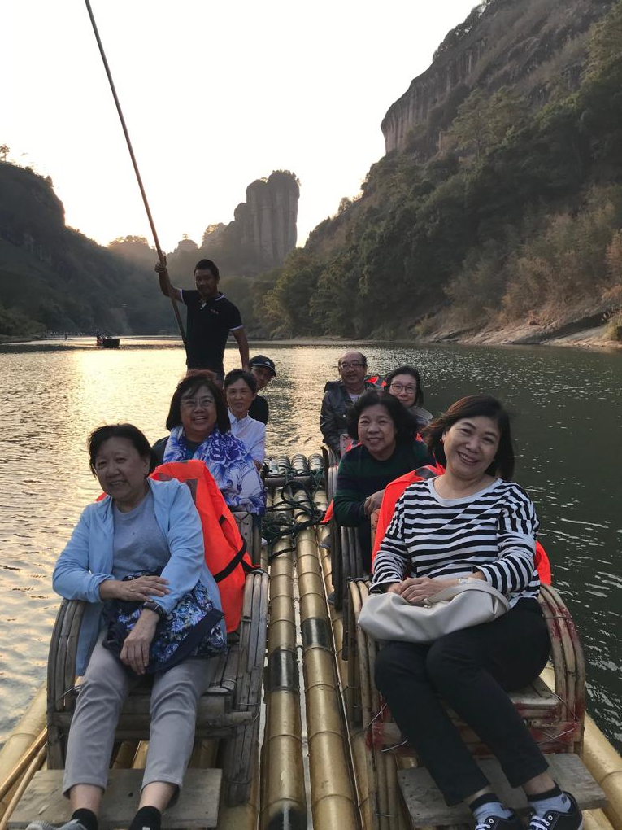  As we learned the history and culture of our ancestry province in Fujian crossing Guangdong, we easily lapsed into our own dialects in Teochew, Hokkien, Cantonese, Hakka during this trip. The locals were surprised at the variety of dialects we spoke. Many of us became aware of the hardship and the resilience of our forefathers who migrated south to Nanyang. “The Fujians are like its Banyan tree榕树 taking root easily wherever whenever落地生根” – tour guide Xiao Pan.  Eat, drink (Fujian tea), shop and laughter filled our days!  - Elaine Tan, member of the traveling team  *****  Next Travel Community Meeting  Date/Time: Sat 23rd Nov @ 11am  Place: Peninsula Plaza  Agenda: 2020 Travel Plan

